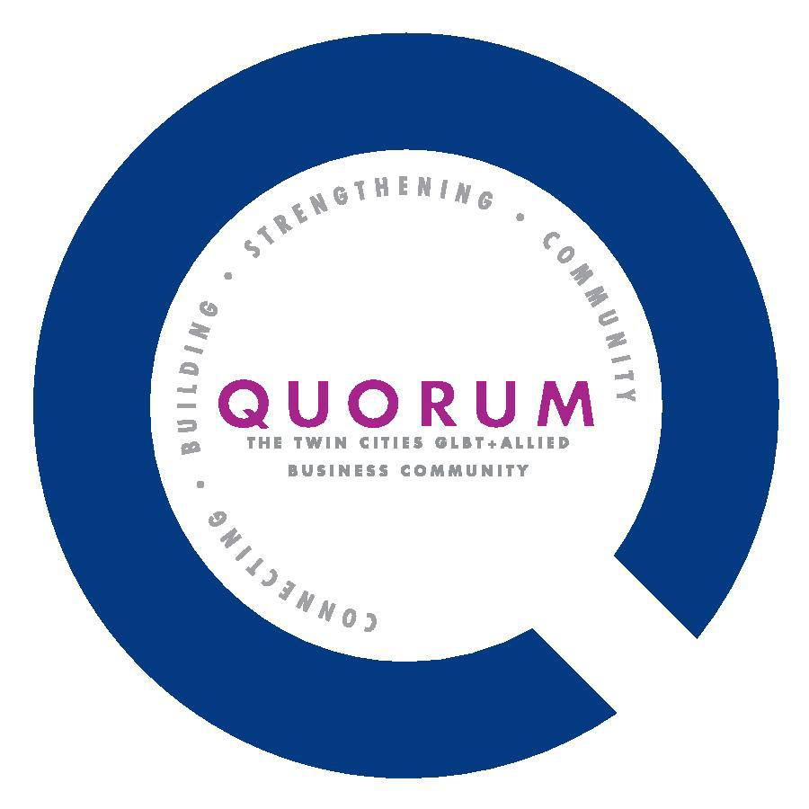Quorum Community Leadership Awards
Name of Nominee:
 | PHONE | EMAIL
NOMINEE’S INFORMATION
YOUR INFORMATION

AWARD CATEGORY:  (Please select up to 3 categories in numerical order) | - Business of the Year  - Nonprofit of the Year  - Business Leader of the Year | - Inclusion Leader of the Year  - Lifetime Achievement Award  - Corporate Equality Partner

Tell Us About your Nominee!
- How does your nominee’s Leadership inspire you?

- What particular accomplishments has this Leader had that you consider most important?

- Describe the impact of this Leader on the broader Community.

- Please detail any additional information that you would like our nominating committee to have including your nominee’s contributions to the business, corporate and/or the nonprofit sector.

Please scan or attach additional information/supporting documents and send completed nomination forms to: awards@twincitiesquorum.com.

Community Leadership Awards: CATEGORIES AND CRITERIA
Quorum Business of the Year
- Demonstrates excellence and success in business or profession
- Visibly supports the LGBTA community by providing contributions and/or in-kind services and other support to nonprofit organizations, political issues, or other community-wide causes
Quorum Corporate Equality Partner of the Year
- Demonstrates excellence and success in business or profession
- Visibly supports the LGBTA community by providing contributions and/or in-kind services and other support to nonprofit organizations, political issues, or other community-wide causes
- Recipient is not required to be be a member of Quorum but is required at minimum to be a member of the NGLCC (National Gay and Lesbian Chamber of Commerce)
Quorum Nonprofit of the Year
- Is a nonprofit with 501(c)3 status
- Openly supports issues and/or provides services that benefit and enhance the health, spirit, pride, and diversity of the lesbian, gay, bisexual and transgender individuals in our community
Quorum Business Leader of the Year
- Demonstrates excellence and success in business or profession
- Demonstrates leadership in the community through volunteer activities and/or serving as a positive role model for others
Quorum Inclusion Leader of the Year
- Demonstrates leadership that creates an environment that embraces the inclusion of all voices and perspectives
- Demonstrates a commitment to creating a fully inclusive organizational culture
- Openly supports issues and/or provides services that benefit and enhance the health, spirit, pride, and diversity of the lesbian, gay, bisexual and transgender individuals in the workplace
- NOTE: The recipient of this award may be an individual or an organization
Quorum Lifetime Achievement Award
- Demonstrates significant leadership benefiting the LGBTA community across the span of the individual's personal and/or professional life
- NOTE: The individual recipient of this award is not required to be a Quorum member

